**POWER QUERY - LEVEL 1**

**ITEM #1: WHAT IS POWER QUERY?**

**Power Query** is a platform to READ (Extract), OPERATE (Transform) and LOAD any data into Power BI. Using Power Query we can perform Union, Merge, Sort, Search, Pivot, Group By, Replace, Filter, etc...

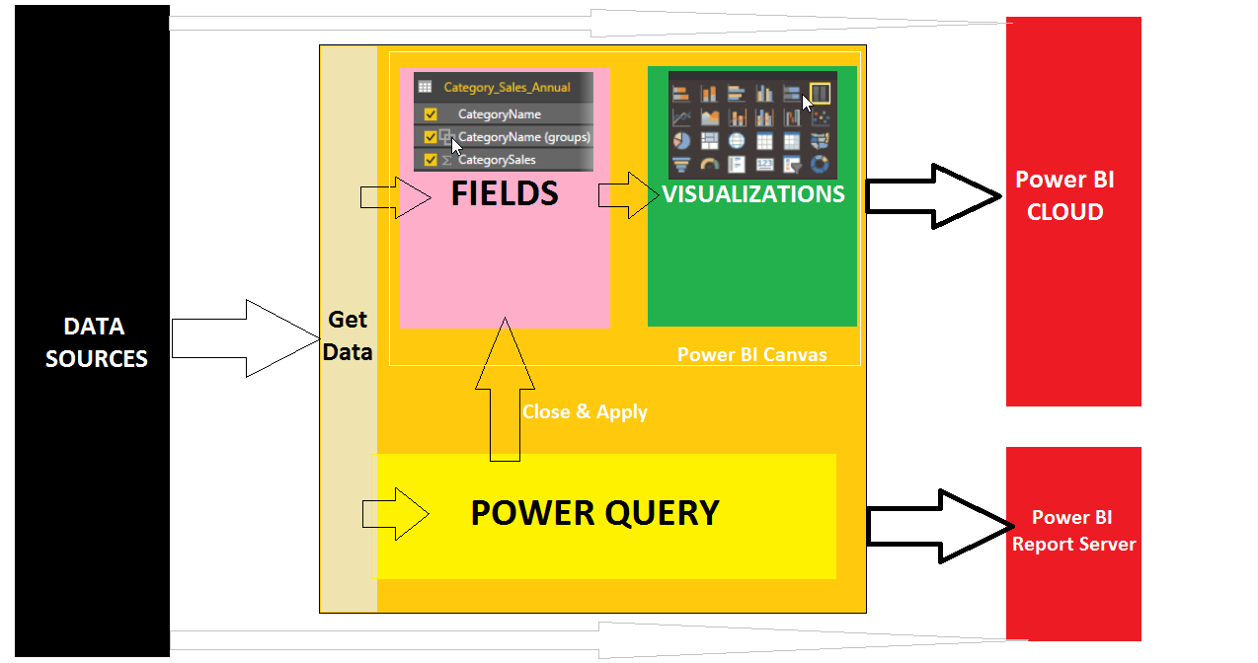

**ITEM #2: WHAT OPERATIONS WE CAN PEFORM USING POWER QUERY?**

**OPERATION 1: "GET DATA" [STATIC or DYNAMIC]**

**OPERATION 2: TRANSFORMATIONS [Operations, Calculations]**

**OPERATION 3: LOAD DATA INTO POWER BI CANVAS FOR REPORTING**

**ITEM #3: WHAT ARE THE TYPES OF QUERIES IN POWER QUERY ?**

|  |  |  |  |
| --- | --- | --- | --- |
| **1** | **TABLE QUERIES** | **4** | **FUNCTION QUERIES** |
| **2** | **LIST QUERIES** | **5** | **RECORD QUERIES [JSON & AZURE TABLES]** |
| **3** | **PARAMETER QUERIES** |  |  |

**ITEM #4: WHAT ARE THE DATA TYPES FOR ABOVE VALUES IN POWER QUERY ?**

|  |  |  |
| --- | --- | --- |
|  |  |  |
| Decimal Number | Date and Time | Text |
| Fixed Decimal Number | Date | True / False |
| Whole Number | Time | Binary |
| Percentage | Date / Time / TimeZone | **Any** [default data type] |

**ITEM #6: WHAT ARE THE TYPES OF TRANSFORMATIONS IN POWER QUERY?**

|  |  |  |
| --- | --- | --- |
| **1** | **TABLE TRANSFORMATIONS** | COMBINE; GROUP BY; TRANSPOSE; REVERSE ROWS; COUNT ROWS; |
| **2** | **ANY COLUMN TRANSFORMATIONS** | DATA TYPE CONVERSIONS ; RENAME; REPLACE; FILL UP; FILL DOWN; |
| **3** | **TEXT TRANSFORMATIONS** | PROPER; SPLIT; FORMAT; MERGE; EXTRACT; PARSE; UPPERCASE; |
| **4** | **NUMBER TRANSFORMATIONS** | STATISTICAL, MATHEMATICAL, EXPONENTIAL, TRIGNOMETRIC.. |
| **5** | **DATE, TIME TRANSFORMATIONS** | DATE; TIME; DURATION; |
| **6** | **STRUCTURED COLUMN TRANSFORMATIONS** | ALTERNATE LIST; DUPLICATE LIST; KEEP TOP ROWS; KEEP BOTTOM ROWS; RANGE OF ROWS; REMOVE DUPLICATES; REMOVE ERRORS; |

**ITEM #7: WHAT IS THE FORMAT FOR POWER QUERY SCRIPT**?

**FORMAT 1: E L**

let source=XXXXXXXXXXXXXXXXXXXX -- FOR DATA **E**XTRACTION, OPTIONAL TRANSFORMATION

in source -- FOR DATA **L**OADING

**FORMAT 2: E T L**

let source=XXXXXXXXXXXXXXXXXXXX -- FOR DATA **E**XTRACTION

STEP1=yyyyyyyyyyyyyyyyyyyyyyyyy -- **T**RANSFORMATION 1

STEP2=zzzzzzzzzzzzzzzzzzzzzzzzz -- **T**RANSFORMATION 2

................................ -- **T**RANSFORMATION n

in STEPn -- FOR **L**OADING OUTPUT OF TRANSFORMATION

**ITEM #8: WHAT IS STEP?**

Step is an operation. Every operation we perform in Power Query results in a "STEP".

We can EDIT an Step; DELETE a Step; INSERT a Step; REORDER a Step;

**PRACTICE EXAMPLES**

**ITEM #9: HOW TO IMPORT EXCEL (OR ANY OTHER) DATA SOURCE INTO POWER QUERY?**

**LAUNCH POWER BI > GET DATA >** EXCEL > BROWSE FOR THE GIVEN SALES DATA >

IMPORT > SELECT THE THREE SHEETS FROM THE FILE. FOR EVERY SHEET, ONE TABLE (ENTITY) IS AUTO DEFINED IN "IN-MEMORY XVELOCITY VERTIPAQ DATABASE".

**CUSTOMER REQUIREMENT:**

**TO REPORT COUNTRY WISE TOTAL SALES 2016**

ISSUE: SELECT A TABLE VISUAL > INCLUDE FEW COLUMNS FROM GERMANY TABLE. THEN TRY TO INCLUDE FIELDS FROM INDIA TABLE. THEN WE SEE AN ERROR. **REASON: NO RELATION**

SOLUTION: COMBINE DATA USING POWER QUERY AND DERIVE A NEW TABLE

**ITEM #10: HOW TO "COMBINE" ABOVE THREE QUERIES (TABLES) USING POWER QUERY?**

**OPTION 1: UNION OR APPEND [ONE BELOW THE OTHER]**

**OPTION 2: MERGE [ONE BESIDE THE OTHER = JOIN]**

**UNION OR APPEND :** RIGHT CLICK GERMANY > EDIT QUERY > THEN WE SEE "POWER QUERY" WINDOW.SELECT "GERMANY" QUERY > TOP : RIGHT > COMBINE > APPEND QUERIES > APPEND AS NEW [MEANS : NEW TABLE QUERY IS CREATED] > THREE OR MORE TABLES > ADD INDIA & USA TABLES > OK. RIGHT CLICK THE RESULTED QUERY > RENAME.

**MERGE:** SELECT "GERMANY" QUERY> TOP : RIGHT > COMBINE > MERGE QUERIES > MERGE QUERIES AS NEW >SELECT "INDIA" QUERY > SELECT COMPARABLE COLUMN(S) :

COMPANY >INNER JOIN >OK. THIS RESULTS A NEW TABLE : GERMANY, INDIA DATA SIDE BY SIDE. SELECT ABOVE MERGE OUTPUT > COMBINE > MERGE QUERIES > MERGE QUERIES >

SELECT "USA" QUERY >> SELECT COMPARABLE COLUMN(S) : COMPANY >INNER JOIN >OK

RIGHT CLICK THE RESULTED QUERY > RENAME.

**ITEM #11: HOW TO VERIFY AUTO GENERATED POWER QUERY SCRIPT FOR ABOVE QUERIES?**

RIGHT CLICK THE QUERY > ADVANCED EDITOR > WE SEE THE POWER QUERY.

**ITEM #12: HOW TO LOAD POWER QUERY RESULTS INTO POWER BI CANVAS FOR REPORTING?**

FROM POWER QUERY WINDOW > HOME PAGE > CLOSE & APPLY.

THIS RESULTS IN EXTRA TABLES AND FIELDS IN POWER BI REPORT DESIGN ENVIRONMENT.

**ITEM #13: HOW TO REPORT FROM ABOVE NEW QUERY TABLES? EX: APPENDED TABLE**

FROM VISUALIZATIONS > SELECT TABLE VISUAL. EXPAND "ALL COUNTRY" TABLE OR ANY OTHER ABOVE RESULT > SELECT FIELDS (COUNTRY, COMPANY, SALES 2016, SALES 2017.. ) > SAVE PBIX.

**ITEM #14 HOW TO "DUPLICATE" THE POWER QUERY TABLES? XEROX COPY**

DUPLICATING THE QUERY WILL RESULT IN ONE ADDITIONAL, ISOLATED (INDEPENDANT) COPY OF THE SOURCE QUERY. COMPLETE QUERY STRUCTURE AND DATA ARE DUPLICATED.

USED FOR FASTER TRANSFORMATIONS ON EXISTING POWER QUERY TABLES.

RIGHT CLICK ANY OF THE ABOVE TABLES FROM THE CANVAS > EDIT QUERY > THIS BRINGS US POWER QUERY WINDOW. RIGHT CLICK AllCountry QUERY TABLE > DUPLICATE. RENAME

**ITEM #15: HOW TO "REFERENCE" THE POWER QUERY TABLES? MIRROR COPY [LIVE]**

REFERENCING THE QUERY WILL RESULT IN ONE ADDITIONAL, AUTO SYNC (DEPENDANT) COPY OF THE SOURCE QUERY. NO DATA IS DUPLICATED. ONLY STRUCTURE IS DUPLICATED.

MEANS : IF WE PERFORM ANY CHANGES TO THE SOURCE QUERY THEN REFERENCE QUERY ALSO GETS THE SAME CHANGE AUTOMATICALLY. USED FOR LIVE DATA SOURCES OF BIGGER SIZE.

**EX:**

RIGHT CLICK AllCountry QUERY TABLE > REFERENCE. RENAME

RENAME COLUMN IN THE SOURCE (AllCountry). VERIFY THE SAME CHANGE IN THE REFERENCE.